Resources Available for Marine Debris Management in Átl'ka7tsem/Howe Sound

October 2023

Compiled by: Rebecca McDonald, Marine Debris Coordinator 2023, Átl'ka7tsem/Howe Sound Marine Stewardship Initiative

Purpose

The compilation of resources is intended to serve as a starting point for individuals or organizations wishing to address marine debris issues in Átl'ka7tsem/Howe Sound (A/HS). Resources may address immediate concerns (ex. A derelict dock has washed up on a beach in my community! What do I do?) or may provide information for higher level planning purposes (ex. How can my community work with government to advocate for better enforcement of laws preventing marine dumping?).

We hope this guide it helpful! We aim for this guide to be a living document– to suggest an addition/edit to this list, please reach out to the Átl'ka7tsem/Howe Sound Marine Stewardship Initiative here: https://howesoundguide.ca/contact-us/ or marinestewardshipinitiative@gmail.com

How to Use This Resource Guide

Resources outlined in this guide range are organized into the following groups as follows:
- Reporting
- Disposal
- Data Visualisation/Mapping
- Reference Documents
  - Marine Debris
  - Legal
  - Local Waste Management Plans
- Cleanup Funding
- Relevant Organizations/Groups
- Education & Advocacy

*Resources specific to Átl’ḵa7tsem/Howe Sound and/or Sea to Sky region are bold, underlined, and italicized*.

Available resources may vary based on the physical location of debris within A/HS. In situations where a resource is only available in a certain area of A/HS, this will be indicated.
Certain resources on this list are designed to address certain sizes/types of debris. Where relevant throughout this document, icons will be used to designate what size/type of debris this resource is aimed at addressing. More than one icon may be attributed to a single resource.

- The circle icon (🟠) indicates resources that are designed to address small or easily accessible debris. This includes small, non-hazardous rubbish on shorelines that are accessible to the public or residents. These resources are often more supportive in nature; cleanup efforts are often undertaken by members of the public themselves. Though not listed, engaged and caring local community members are an extremely important (if not the most important) resource!

- The square icon (🟧) indicates resources that are related to medium sized debris (too big for the garbage bin) or debris that is inaccessible or unsafe for members of the public to address themselves. These resources are often reporting related, with organizations/contractors undertaking and/or supporting actual cleanup efforts.

- The diamond icon (🔶) indicates resources that may be used to address marine debris that would require the involvement of a government agency or highly trained contractor. This includes large debris (ex.dumped industrial equipment), large/sunken derelict vessels, navigational hazards, and emergency situations.

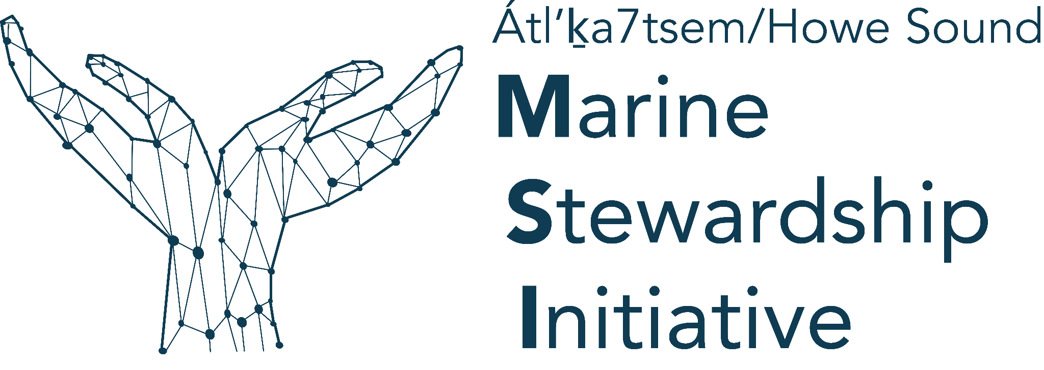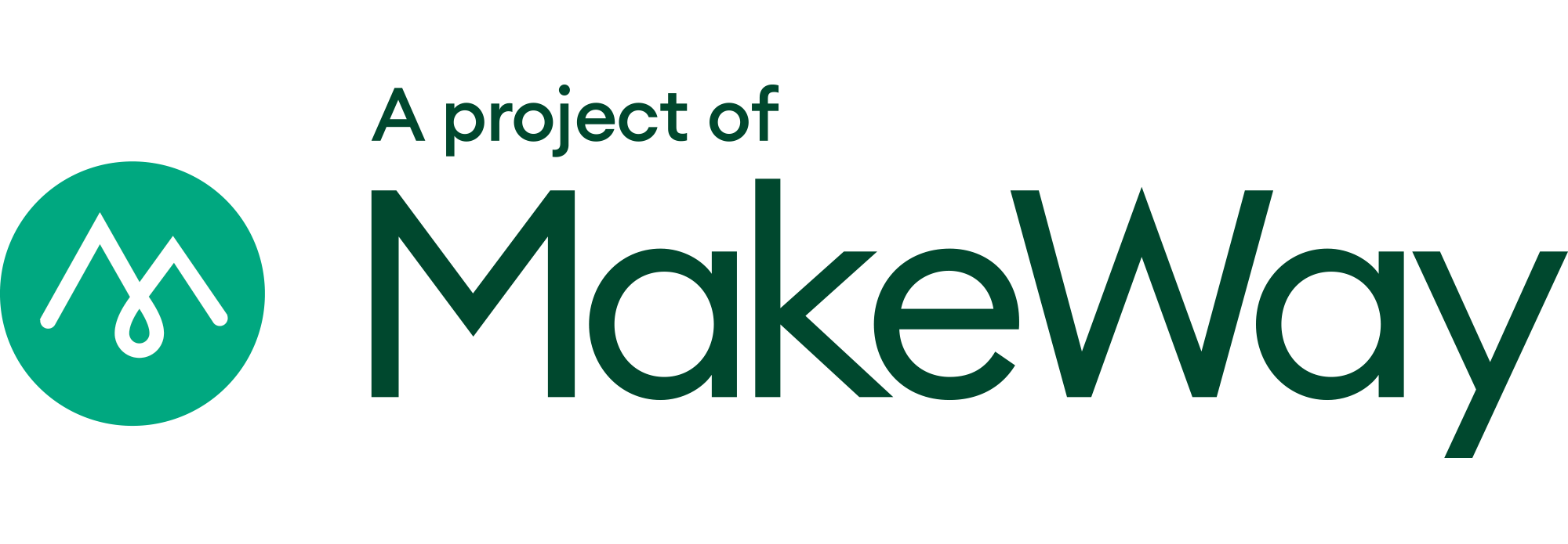

Marine Debris Reporting

- 🟧🔶Marine Debris Reporting Tool (Átl’ḵa7tsem/Howe Sound Marine Stewardship Initiative)
  - 24/7 accessible tool available to public to report marine debris within Átl’ḵa7tsem/Howe Sound
  - Meant to address marine debris that cannot be safely cleaned up or disposed of by members of the public without additional assistance (eg. too big, inaccessible, hazardous)
  - Access the tool here: https://survey123.arcgis.com/share/31ba766dd7ac4555844753d74fc73356

- 🟧🔶Derelict Boat and Marine Debris Reporting Tool (Dead Boat Disposal Society)
  - Reporting form to alert the dead boat disposal society of derelict boats and/or other marine debris
  - The MSI Marine Debris Reporting tool directs users to submit a second report here in certain cases (eg. derelict boats)
  - Access the form here:https://deadboatsdisposalsociety.ca/report-an-issue/

- 🟧🔶The Report All Poachers and Polluters (RAPP) hotline (BC Government)
  - Hotline and online reporting tool may be used to report known or suspected violations of fisheries, wildlife, or environmental protection laws.
  - Environmental violations to report includes "illegal waste disposal, such as household or business waste and waste dumped on Crown Land".
  - Call 1-877-952-7277 or #7277 on the TELUS Mobility Network.
  - In non-emergency situations use the online RAPP reporting tool here: https://forms.gov.bc.ca/environment/rapp/
  - Find more info here: https://www2.gov.bc.ca/gov/content/environment/natural-resource-stewardship/natural-resource-law-enforcement/conservation-officer-service/cos-rapp

- 🔶To report marine debris that is a threat to public safety or is a navigational hazard gg(Federal government)
  - Contact your nearest Canadian Coast Guard Marine Communications and Traffic Services (MCTS) centre
    - VHF channel 16 (156.8 MHZ)
    - MF/HF frequency 2182 kHz/4125 kHz (where available)
    - *16 on a cellphone (where available)
  - More info: https://www.ccg-gcc.gc.ca/contact/mcts-contact-stcm-eng.html

🟧🔶BC Wildlife Federation (BCWF) Conservation App (for iPhone and Android)

The BCWF Conservation app allows users to quickly report environmental infractions related to natural resource use/abuse with a few clicks. The app uploads GPS data into the BCWF map and automatically fills in a R.A.P.P. violation report. Additionally, BCWF pays rewards of up to $2,000 for information leading to a conviction of persons who have violated laws related to fish, wildlife, or the environment
  - More info here: https://bcwf.bc.ca/initiatives/conservation-app/

- 🟧🔶Report a Spill Hotline (BC Government)
  - When a spill or the risk of a spill occurs, report it immediately by calling 1-800-663-3456.
  - More info here: https://www2.gov.bc.ca/gov/content/environment/air-land-water/spills-environmental-emergencies/report-a-spill

- 🟧🔶BC Marine Mammal Response Network (Observe, Record, Report) (Federal gggggGovernment)
  - Report marine mammals or sea turtles injured, strangled, entangled, or killed by marine debris (or in general)
    - 1-800-465-4336
    - DFO.ORR-ONS.MPO@dfo-mpo.gc.ca
    - VHF Channel 16
  - More info here: https://www.dfo-mpo.gc.ca/species-especes/mammals-mammiferes/report-rapport/page01-eng.html
Marine Debris Disposal

- 🟠🟧🔶Sechelt Ocean Plastics Depot (Ocean Legacy Foundation and Sunshine Coast ggggggggRegional District)
  - Marine debris collected through beach clean ups can be diverted from being buried through the newly established ocean plastics depot, at the Sechelt Landfill. Items like beach foam, netting and ocean plastics will be transported for recycling through a partnership with the SCRD and the Ocean Legacy Foundation.
  - The depot is available to small-scale shoreline cleanups by residents or community groups at no charge. Larger scale residential, commercial or industrial dock renovations and end of life materials will not be accepted at the depot and should contact Ocean Legacy directly.
  - A short orientation is required to use the depot for the first time. More information available here: https://www.scrd.ca/ocean-depot/#:~:text=Marine%20debris%20collected%20through%20beach,depot%2C%20at%20the%20Sechelt%20Landfill
  - Accepted materials outlined here: https://www.scrd.ca/wp-content/uploads/2023/03/Accepted-at-the-Ocean-Depot.pdf

- 🟠🟧Good Samaritan Program (SCRD)
  - If you find items that are not accepted at the ocean plastics depot while cleaning up a site (within SCRD boundaries only), the SCRD Good Samaritan Program may be relevant
  - This program pays the landfill tipping fees for materials collected from illegal dump sites cleaned up by volunteers. Pre-approval is required to have the disposal fees funded by this program
  - If you have found a dump site and would like to clean it up, contact the SCRD in advance at 604-885-6806 or email infrastructure@scrd.ca.
  - More info available here: https://www.scrd.ca/illegal-dumping/

- 🟠🟧🔶Extended Producer Responsibility Programs (EPR)
  - Extended Producer Responsibility (EPR) is an approach to recycling that requires producers, such as manufacturers, distributors, and retailers to take responsibility for the life cycle of the products they sell
  - Certain programs may be relevant in the disposal of some marine debris
  - Tires are commonly found as marine debris in Howe Sound, so Tire Stewardship is a particularly relevant EPR
    - Tire Stewardship BC
https://tsbc.ca/
  - Find more information on EPF programs in BC here: https://www2.gov.bc.ca/gov/content/environment/waste-management/recycling/extended-producer-responsibility#:~:text=Extended%20Producer%20Responsibility%20(EPR)%20is,curbside%20collection%20or%20collection%20depots

Mapping/Data

- 🟧🔶Marine Reference Guide: Átl’ḵa7tsem/Howe Sound Marine Stewardship Initiative
  - Marine Reference Guide map - Publicly accessible map layer displaying marine debris observations collected from our marine debris reporting system
  - To view marine debris data:
- Locate layers button (top righthand corner of map)
- Human Use> Pollution> Marine Debris Reporting Survey
- Toggle Marine Debris Reporting Survey
“On” using checkbox
- Individual red data points may then be selected (point and click) to display additional information.
  - Access the guide here: https://howesoundguide.ca/marine-reference-guide/

Reference

Marine Debris
- 🟧How to Plan a Marine Debris Cleanup Guide (Ocean Legacy)
  - This strategic framework provides an overall structure and instruction in how to comprehensively plan a cleanup for rural and urban areas
  - Access the guide here: https://epic.oceanlegacy.ca/wp-content/uploads/2019/09/Ocean-Legacy-Strategic-Cleanup-Framework.pdf?_ga=2.72750801.313454146.1695096641-41726081.1689023563&_gl=1*1jc8rpl*_ga*NDE3MjYwODEuMTY4OTAyMzU2Mw..*_ga_XNQBQPL8F6*MTY5NTA5NjY0MC4xMC4xLjE2OTUwOTcwNTAuMC4wLjA.*_ga_E3KBBQ3BMK*MTY5NTA5NjY0MC4xMC4xLjE2OTUwOTcwNTAuMC4wLjA.
- 🟠🟧Ocean Plastic Depot, Marine Debris Sorting Guide (Ocean Legacy)
  - This guide outlines what types of materials are accepted by the Ocean Plastic Depot in Sechelt. It also directs users how to sort materials during drop off. This guide is useful to have in the field while conducting marine debris cleanups as sorting debris as it collected avoids having to sort through material afterwards.
  - Access the guide here: https://www.scrd.ca/wp-content/uploads/2023/03/Accepted-at-the-Ocean-Depot.pdf

- 🟧🔶Best Practises for Marine Dock Management (HSBRIS)
  - The Átl’ka7tsem//Howe Sound Biosphere Region Initiative Society has compiled these Best Management Practices (BMPs) that are intended to help minimize and mitigate impacts to marine foreshore and nearshore habitats by promoting responsible and appropriate development, construction, and maintenance of marine docks.
  - Access the document here: https://www.howesoundbri.org/webinars/2021/3/31/best-practices-for-marine-dock-management

- “Addressing abandoned vessels, marine debris and marine-sourced plastics in B.C” (BC government)
  - BC government webpage
  - Access here: https://www2.gov.bc.ca/gov/content/environment/waste-management/zero-waste/marine-debris-protection

- Coastal Marine Strategy (BC Government)
  - In development, anticipated completion = Spring 2024
  - More info here: https://engage.gov.bc.ca/govtogetherbc/engagement/coastal-marine-strategy/

- What We Heard on Marine Debris in BC (2020)
  - BC gov report
  - Highlights obstacles faced by communities, ideas to address these obstacles and the innovative solutions and programs developed by local groups
  - Access report here: https://www2.gov.bc.ca/assets/gov/environment/waste-management/zero-waste/marine-debris-protection/marine_debris_what_we_heard_report_final_web.pdf

- Marine Debris and Marine-sourced Plastics Report (2019)
  - BC gov report
  - Updates interested parties on the project, provides a snapshot of What We Heard and presents some next steps
  - Access report here: https://www2.gov.bc.ca/assets/gov/environment/waste-management/zero-waste/marine-debris-protection/marine_debris_engagement_fall_factsheet.pdf

- CleanBC Plastics Action Plan
  - Access plan here: https://engage.gov.bc.ca/app/uploads/sites/752/2022/04/CleanBC_Single-Use-Plastics_Intentions-Paper.pdf

Local Regional District Waste Management Plans

- Squamish Lillooet Regional District Solid Waste and Resource Management Plan (2016)
  - Access here: https://www.slrd.bc.ca/sites/default/files/reports/SLRD%20SWRMP%202016-03-16_Final_Draft.pdf

- Sunshine Coast Regional District Solid Waste Management Plan – The Foundation for Zero Waste Plan (2011)
  - Access here: https://www.scrd.ca/wp-content/uploads/2022/12/SWMP-Final-Report-Proofed-10-31-11-w-AppB-WEB.pdf

*New SCRD plan in development at the time of resource compilation (Oct. 2023)

- Greater/Metro Vancouver Regional District Integrated Solid Waste and Resource Management (2010)
  - Access here: https://metrovancouver.org/services/solid-waste/Documents/integrated-solid-waste-resource-management-plan.pdf

*New MVRD plan in development at the time of resource compilation (Oct. 2023)

Legal Info

Protecting the Coast and Ocean: A Guide to Marine Conservation Law in British Columbia (2020)

West Coast Environmental Law

Access here: https://www.wcel.org/publication/protecting-coast-and-ocean-guide-marine-conservation-law-british-columbia

- Bill C-64: Wrecked, Abandoned or Hazardous Vessels Act (2019)
  - It made it illegal to abandon a boat in Canada and gives the government the power to go after boat owners when their vessels are wrecked or left behind, including fines up to $1 million.
  - The law is both meant to be a deterrent to abandoning a boat, but also to allow the government to hold owners liable for the costs of removal if they do it anyway.
  - Details here: https://laws-lois.justice.gc.ca/eng/acts/W-12.3/
Cleanup Funding

- 🟧🔶Clean Coast Clean Waters Initiative Fund
  - The Fund is directed toward marine coastal First Nations, Indigenous organizations and local governments in BC, as well as BC non-profits and organizations / individuals that have expertise in shoreline and marine debris clean-up and/or removal of derelict vessels.
  - The Fund will support two types of projects:
    - Marine shoreline clean-up: Conduct and coordinate shoreline clean up in marine coastal BC locations.
    - Derelict vessel removal: Conduct and coordinate derelict vessel removal in coastal BC locations.
  - More information available here: https://bccleancoast.ca/

- 🔶Átl'ka7tsem/Howe Sound Marine Debris Fund
  - In discussion/development as of October 2023….
  - Contact Howe Sound Biosphere Region Society for more information here: https://www.howesoundbri.org/contact

Organizations & Groups

Átl'ka7tsem/Howe Sound Relevant

Organizations that actively undertake or support marine debris cleanup efforts in Átl'ka7tsem/Howe Sound (current or recent)

- 🟠🟧🔶Átl'ka7tsem/Howe Sound Marine Stewardship Initiative
  - Supports data collection, reporting, mapping, advocacy, and coordination efforts to manage and prevent marine debris in A/HS
  - Resource for additional information regarding marine debris management in A/HS - reach out with questions here: https://howesoundguide.ca/contact-us/
  - Marine Reference Guide and Marine Debris Reporting Tool
  - More info here: https://howesoundguide.ca/

- 🟠 🟧🔶Howe Sound Biosphere Region Initiative Society
  - Supports advocacy and coordination efforts to mitigate marine debris in A/HS
  - More info here: https://www.howesoundbri.org/

- 🟧🔶The Ocean Legacy Foundation (OLF)
  - A Canadian based non-profit organization that was founded in 2013 with the goal to end ocean plastic waste. OLF will work with communities that are in a plastic pollution crisis through an Emergency Management System (EMS) that incorporates mitigation, prevention, response and recovery measures.
  - They have coordinated/executed multiple cleanup efforts in A/HS in recent years
  - They can provide cleanup supplies and guidance for groups leading their own mid-scale cleanups
  - More info here: https://oceanlegacy.ca/

- 🟠 🟧Nicholas Sontag Marine Education Centre (NSMEC)
  - NSMEC has led marine debris cleanups in A/HS in recent years (in partnership with OLF)
  - More info here: https://gibsonsmarine-ed.org/

- 🟧🔶Dead Boats Disposal Society
  - Research, education, inventory, removal, assessment, remediation, disposal of dead boats and marine debris, from our shores in British Columbia, Canada
  - More info here: https://deadboatsdisposalsociety.ca/

- 🟧🔶Divers for Cleaner Lakes and Oceans
  - An organization of volunteer divers who work hard to make a positive impact on both our freshwater resources as well as our local oceans by performing clean up dives on a regular basis
  - More info here: https://cleanerlakes.com/projects

- 🟠 Great Canadian Shoreline Cleanup
  - Ocean Wise Initiative supports community shoreline cleanups across Canada
  - They also provide any required supplies and coordination support for community shoreline cleanups (anyone can lead a cleanup!)
  - More info here: https://ocean.org/pollution-plastics/shoreline-cleanup/

Other Relevant Organizations

Unknown if these groups have undertaken cleanup efforts in Átl'ka7tsem/Howe Sound but they do undertake marine debris cleanup efforts nearby.

- 🟠🟧Surfriders
  - Vancouver chapter organizes cleanups and education events in the lower mainland
  - More info here: https://vancouver.surfrider.org/events

- 🟧🔶Coastal Restoration Society
  - Non-profit organization supporting the environmental remediation goals of First Nations, provincial, and federal government agencies
  - Can assist in the cleanup of large marine debris or derelict vessels
  - More info here: https://www.coastrestore.com/

Education & Advocacy

- There is a BC government inbox related to marine debris in BC
  - They welcome “thoughts and ideas” on the topic of marine debris in BC
  - Address here: MarineSpecialAdvisor@gov.bc.ca
  - More info here: https://www2.gov.bc.ca/gov/content/environment/waste-management/zero-waste/marine-debris-protection/marine-debris

- Ocean Legacy
  - EPIC Academy- A complete educational curriculum to be taught in the classroom or for online learners wishing to learn the material at their own pace. Suitable for highschool students and up to students of all ages
    - Access here: https://edu.oceanlegacy.ca/?_ga=2.75058838.544930257.1696907000-41726081.1689023563&_gl=1*1fbciqt*_ga*NDE3MjYwODEuMTY4OTAyMzU2Mw..*_ga_E3KBBQ3BMK*MTY5Njk3OTAzMy4xNy4xLjE2OTY5NzkwNDUuMC4wLjA.*_ga_XNQBQPL8F6*MTY5Njk3OTAzMy4xNy4xLjE2OTY5NzkwNDUuMC4wLjA.
  - Marine Debris Solutions Transforming Wasted Plastic into a Valuable Resource
    - Guides science-based education around the effects of plastic pollution in the natural environment and human body
    - Access here: https://oceanlegacy.ca/tolf/wp-content/uploads/2019/04/OL_en_print.pdf
- Ocean Wise
  - Ocean Wise has an Ocean Plastic themed education kit which includes Educator Guidebooks and Student Workbooks
    - Different versions available for Elementary, Middle, and Secondary students
    - An Átl’ḵa7tsem/Txwnéwu7ts/ Howe Sound kit is also available
  - Download free here: https://ocean.org/action/ocean-plastic-education-kit/

